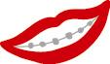

***Mellas Bucks Rewards***

**Mellas Bucks** are a fun and exciting program meant to reward our patients for good behavior and cooperation with their orthodontic treatment. If you come on time to your appointment, brush well, wear your elastics, take care of your appliances and follow our foods list you will earn **Mellas Bucks.**

**Mellas Bucks** are exciting for children and adults… just check out our list of prizes!

Each prize is equal to the number of **Mellas Bucks** required for redemption. Let us know when you’d like to redeem yours for one of our fabulous prizes and we will calculate how many you have earned.

While we are hard at work creating a beautiful smile, let’s have fun!

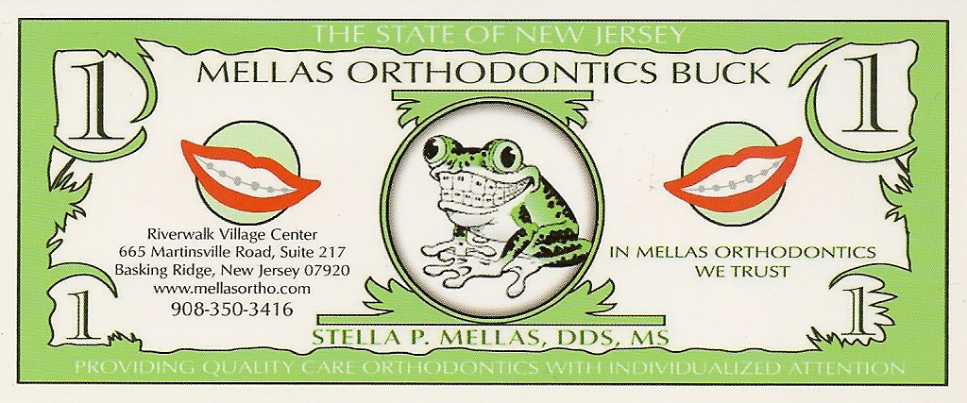

* **$25 Chipotle** Gift Card = 25 Mellas Bucks
* **$25 Best Buy** Gift Card = 25 Mellas Bucks
* **$25 Sephora** Gift Card = 25 Mellas Bucks
* **$25 Amazon** Gift Card = 25 Mellas Bucks
* **$25 Apple** Gift Card = 25 Mellas Bucks
* **$15 Starbucks** Gift Card = 15 Mellas Bucks
* **$25 Barnes and Noble** Gift Card = 25 Mellas Bucks
* You may **DONATE** some or all of your **Mellas Bucks** to **Operation Smile**.A donation will be made to help fund cleft palate, lip and facial deformity surgeries for children around the world.